**Mphasis ATE Capstone Project Medicare Name: Prajwal Diwakar**

**Create a Testing Framework for the Medicare Website**

**Technical Report**

**Postman**

1) Download the postman application in the browser, Create the account and login to the postman application.

2) Once the postman application is ready, create a new workspace by adding the name and summary into the input text.

3) After the creation of the workspace, create the new blank collection and name accordingly.

4) Add the request that is the GET request method , in order to get the products details and the registered users by passing the API link to the address bar.

5) Create the environment and add the variables which can be accessed by all the request method.

6) In order to generate the test results, write the test scripts in the test body.

7) After the response is received, check the data generated is matching to the expected outcome by using the methods in the test scripts of the request.

8) Finally export the collection to the particular folder and upload to the github repository.

9) To run the newman, open the command prompt in the path of the exported files from the postman and type command as newman run <your collection file >.json -e <your environment file>.json

10) To get the code, clone the below github link to your system by typing the command git clone <url> in the command prompt.

Github Link: <https://github.com/Prajwal-Diwakar/Capstone-Project-Medicare>

**Screenshot:**

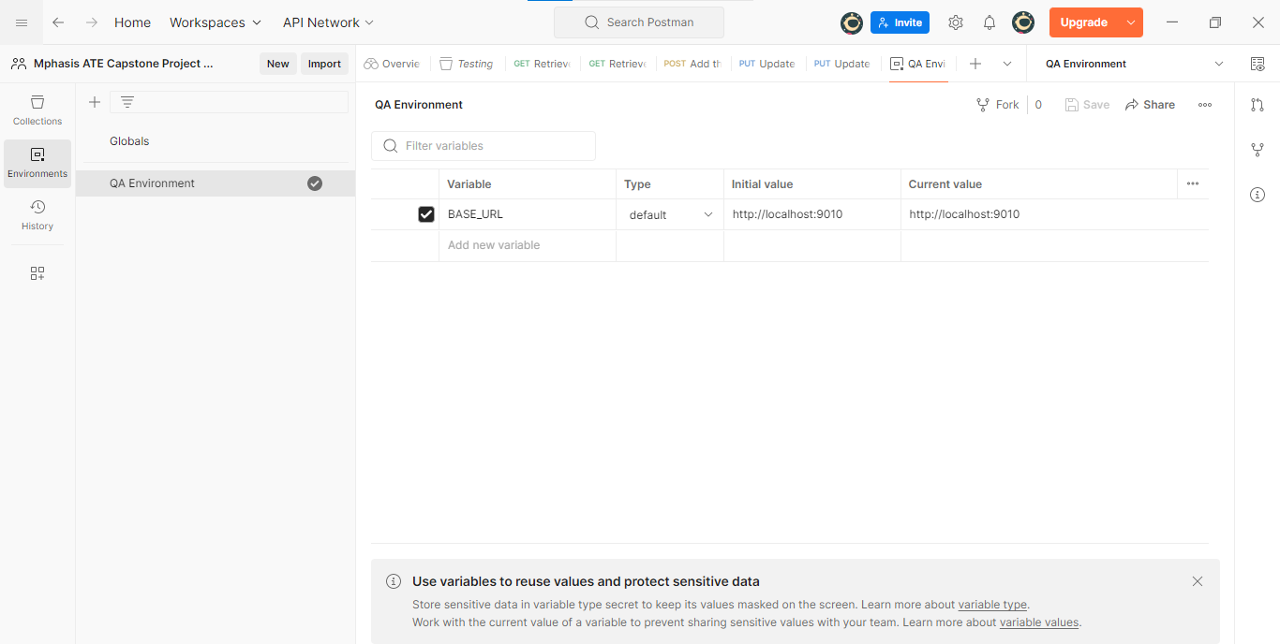

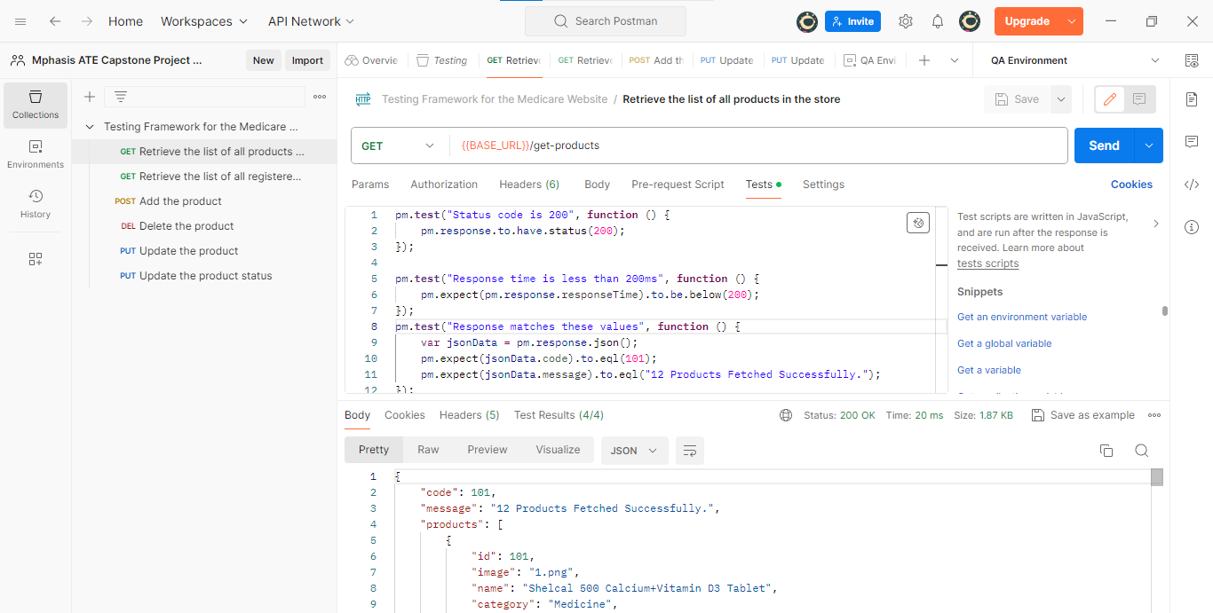

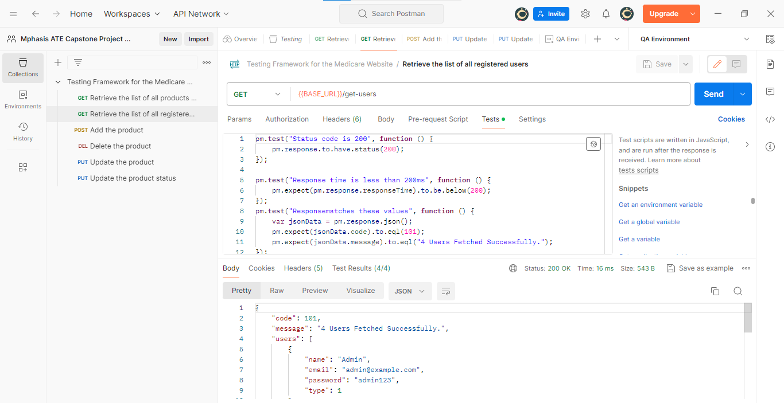

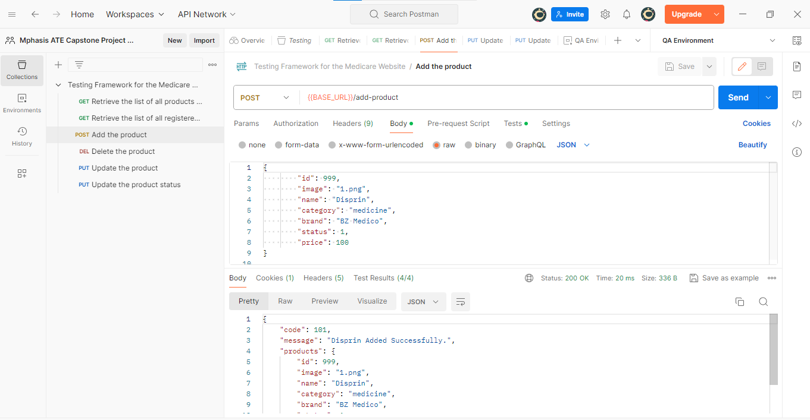

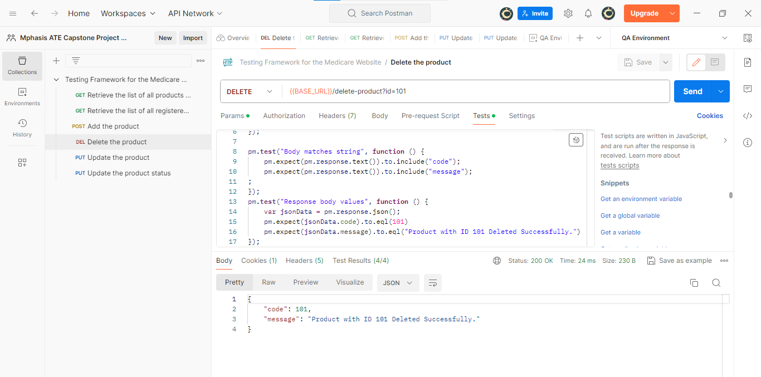

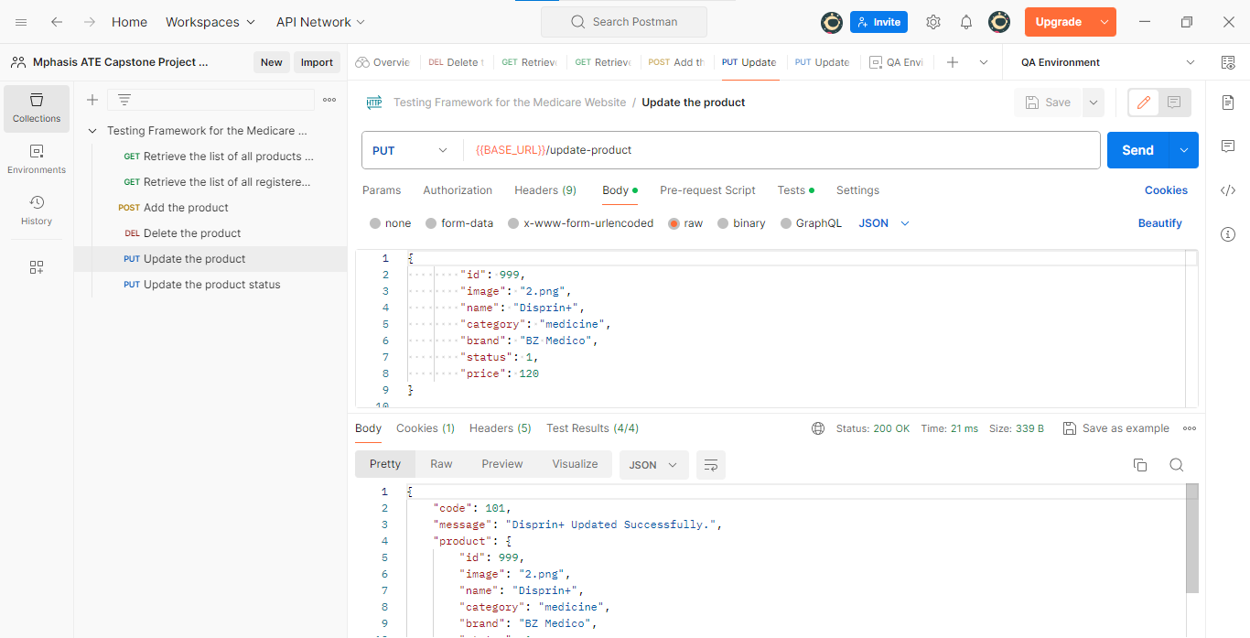

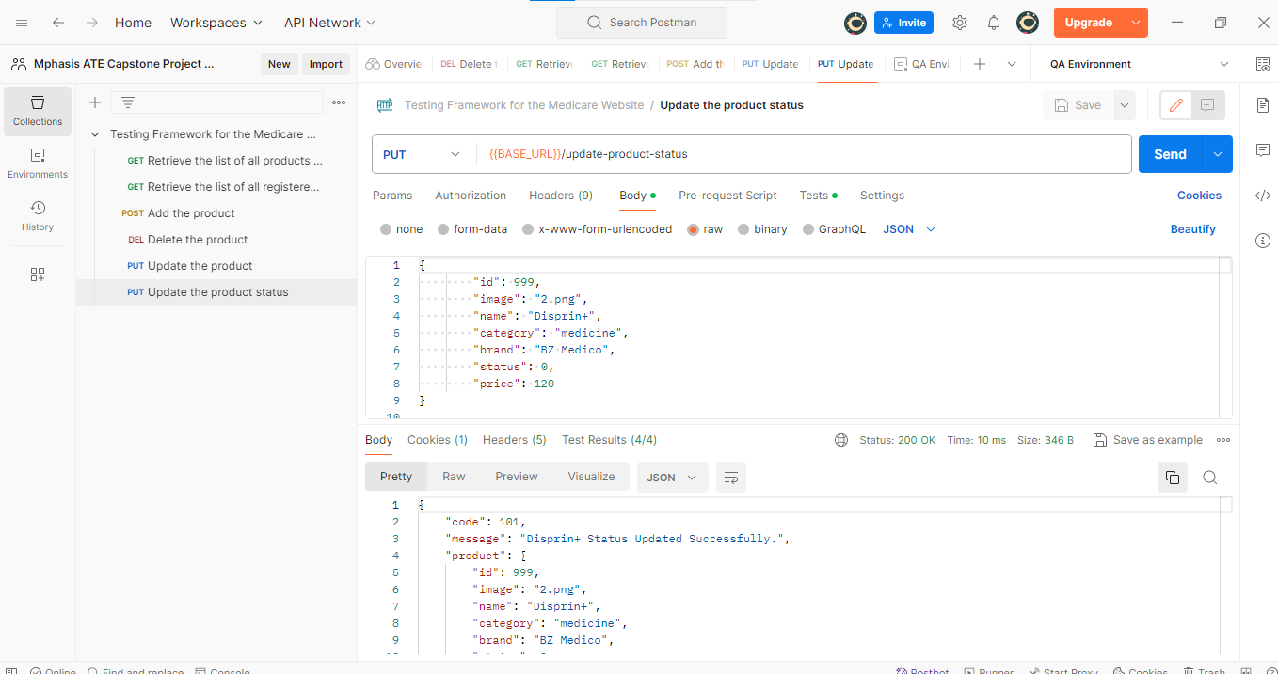

**Run Collection:**

